Jonathan Quang

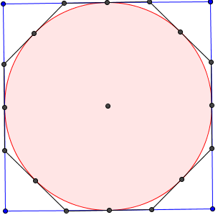 Pi is the ratio of the circumference of a circle to its diameter, used by students since elementary school. However, there is more to pi than a simple ratio. People expect values of pie to be calculated just by pressing a button, but how is it done without a machine? The population of those who know how to calculate the value of pi is much smaller compared to the people who know how to calculate pi.  
 The problem with pi is that it is irrational and transcendental. An irrational number is a number that cannot be expressed as a ratio between integers such as $\frac{2}{3}$. The common approximations of pi are $\frac{22}{7}$ which is only accurate up to two digits, $\frac{333}{106}$ which is accurate only to five digits, and $\frac{355}{113}$. A transcendental number is any number that cannot be expressed as a root of a single variable non-zero polynomial with only rational coefficients. An example of a single variable non-zero polynomial is x2 + 2x + 1. There are several ways to get pi, but a human will never get the exact value of pi.  
 One way to approximate pi is through the application of Pythagoras’s theorem to a circle inscribed in a regular concave polygon and a regular concave polygon inscribed in a circle. Using a circle inscribed in a regular concave polygon inscribed and inscribed in another regular concave polygon with 2 times the number of side will yield a high end approximation. A common polygon to start with is a square. Imagine a circle inscribed within a square and inscribed within an octagon, as in figure 1-1. Say the radius of the circle is 10. The length of one side of a polygon is defined as 2a. The length of a side for a regular concave polygon that has twice the number of sides (the 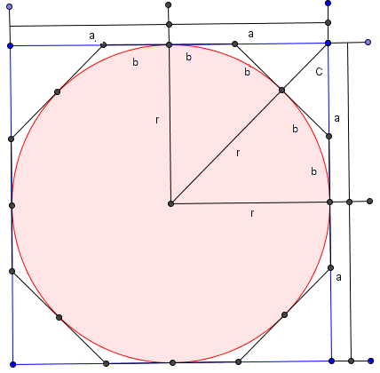octagon) of the other polygon will be represented by 2b. C represents the length described in the picture to the right.. Variables will be used instead of actual   
values because picking values for a, b, or c will be inaccurate   
because they may not be correct. The first goal to achieve in   
calculating pi is finding the ratio of the length of one side of the  
 radius without using the fact that each side of a square is twice   
the radius. To accomplish the first goal, two right triangles are   
defined by their side lengths. Triangle r is defined as having a   
side length of a and a side length of (r+c). Since r represents 10, the side length is (10+c). Triangle b is defined as having a side length of c and (a-b).   
 The next part of finding pi would be applying Pythagoras's theorem to each triangle in the following manner: In triangle r, (10+c) is the hypotenuse. Therefore (10+c)2 = 102 + a2. In triangle b, (a-b) is the hypotenuse. Thus, (a-b)2 = b2 + c2. Going back to the application of Pythagoras's theorem to triangle b, the squares can be multiplied out to form b2 + c2= a2- 2ab + b2. This can be simplified by subtracting b2 from both sides and yields c2= a2- 2ab. Return to the application of Pythagoras's theorem to triangle r, (10+c)2 = 102 + a2, square rooting both sides yields 10+c = $\sqrt{{10}^{2}+ a^{2} }$, which simplifies to c = $\sqrt{{10}^{2}+ a^{2} }- 10$. With these two equations setup in this manner, they both have the variable c in common.  
 If we plug the simplified equation for triangle r into the simplified equation for triangle b, the result is ${(\sqrt{{10}^{2}+ a^{2} }- 10)}^{2}= a^{2}- 2ab.$ If one were to square the equation for triangle r, the result is ${10}^{2}+ a^{2}-2{*10\sqrt{{10}^{2}+ a^{2} }- 10}^{2}$ = $a^{2}- 2ab$. Combining the 102 on the triangle r side of the equation, subtracting a2 from both sides of the equation, and multiplying by -1 yields 2ab=2 ${10\sqrt{{10}^{2}+ a^{2} }-2* 10}^{2}$\*. To isolate b, both sides of the equation should be divided by 2a. This yields b = ${10\sqrt{\frac{{10}^{2}}{a^{2}}+ \frac{a^{2}}{a^{2}} }-\frac{ 10}{a^{2}}}^{2}$. Factoring out the 102 results in b = 102 ). Dividing both sides by 10 results in $\frac{b}{10}=10\left(\sqrt{\frac{1}{a^{2}}+ \frac{1}{{10}^{2}} }-\frac{ 1}{a}\right).$ By doing so, we are finding the ratio of the length of one side to the radius. Redistributing the 10 among the terms in the parenthese yields $\frac{b}{10}=\left.\sqrt{\frac{{10}^{2}}{a^{2}}+ \frac{{10}^{2}}{{10}^{2}} }-\frac{ 10}{a}\right..$ Simplifying this results in $\frac{b}{10}=\left.\sqrt{{\left(\frac{10}{a}\right)}^{2}+1 }-\frac{ 10}{a}\right..$ Here, b is expressed as a ratio to the radius. This leads to the next portion of the algebra.  
 For the sake of clarity, ε will equal to a/10 and β will equal b/10. Substituting these into the equation results in $β=\left.\sqrt{{\left(\frac{1}{ε}\right)}^{2}+1 }-\frac{ 1}{ε}\right.$. The goal of finding the ratio of one side of the polygon with more sides to the radius. In this case, the polygon selected has 4 sides, and the octagon it is inscribed in has 8 sides. 10β represents half the length of one side. If one defines N as the number of sides the polygon with more sides has, then 2N10β would represent the perimeter of the polygon with twice the number of sides as the chosen polygon. The diameter is 2\*10. Dividing the perimeter by the diameter, which is finding the formula for pi, will yield, N\*β. Since this formula relies solely on ratios and not the size of any of the segments, pi is the same regardless of size of the selected polygon.   
 A square and an octagon can be used to show an example of using this formula. β(square) = 1 and pi is about 4. This is due to the fact that the length of one side of a square is equal to the diameter. The perimeter is equivalent to four times the diameter. Consequently, β = 1. Starting with an octagon, the formuls will be applied properly. For the sake of finding pi, ε=1. Applying this to β, β = $\sqrt{2}$-1, or about 0.414. Pi is about N \*β, so pi is about 8 \* 0.414, or 3.312.